developer@simformsolutions.com Simform.321

**Spring Framework**

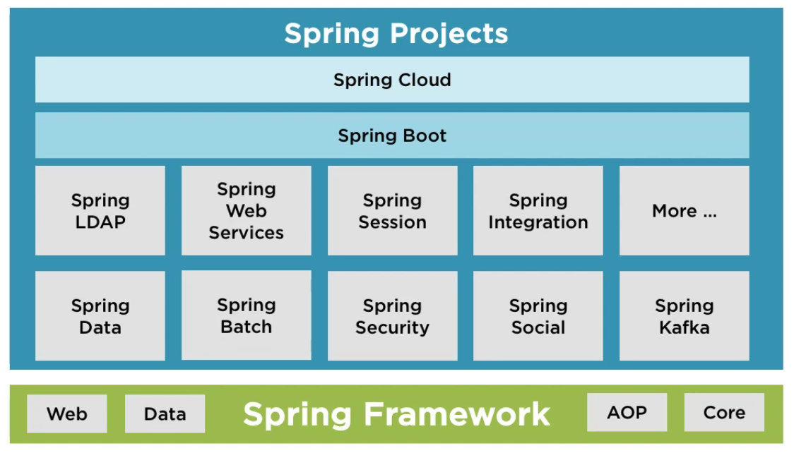

Spring Started as a response to the complexity of J2EE (Now Java EE).

Today, Spring is so much more than an alternative to Java EE. In fact, it is complimentary to java EE.

Spring is,

* Flexible, Modular and backwards compatible
* Has an active and large community
* Continuously innovates and evolves

Spring Boot is,

* **Standalone:** You just run the application. No need to configure and deploy web-server. *Java –jar my-app.jar*
* **Opinionated:** [Spring Initializer](http://start.spring.io)
* Does **auto-configuration:** Automatically configure your spring application based on the dependencies that you have added. Auto-configurations are Contextually aware and smart. Add one annotation “*@EnableAutoConfiguration”* to use auto-configuration.

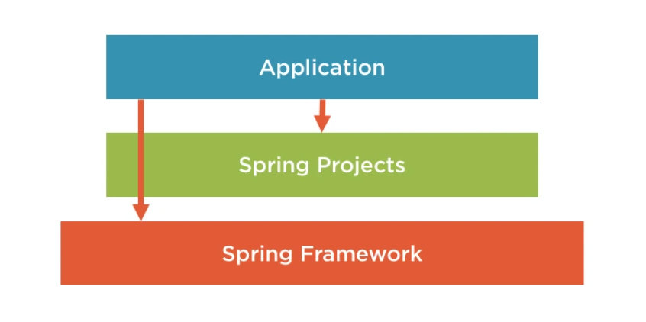

**Spring Framework: six key Areas**

* **Spring Core:** Provides many different features. For example, i18n Internationality support, validation support, Data Binding support, Type conversion support etc. At the center of the Spring core is *Dependency Injection*. Dependency injection is about dealing with the way objects fulfill their dependent objects. Spring core is a dependency injection container, it creates and manages objects and their dependencies.
* **Spring Web:** Framework for handling web requests. Spring web MVC and Spring Webflux.
* **Spring AOP:** AOP is a way of programming that increases organization of code and concerns that span multiple tiers or layers of application. Annotation: @PreAuthorize(hasRole(____))
* **Spring Data Access:** interact with databases. It also Provides Exception Translation. Useful Annotation: @Transactional.

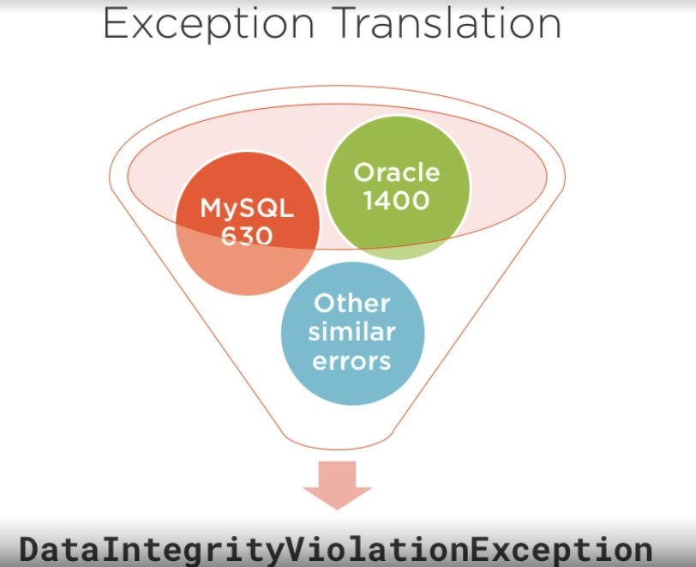

* **Spring Integration:** Spring framework makes it easy to both expose and invoke web services. Provides Rest Templates.
* **Spring testing:**

**JPA is only a specification.** Hibernate, Toplink etc. are its implementations.

**Spring MVC**

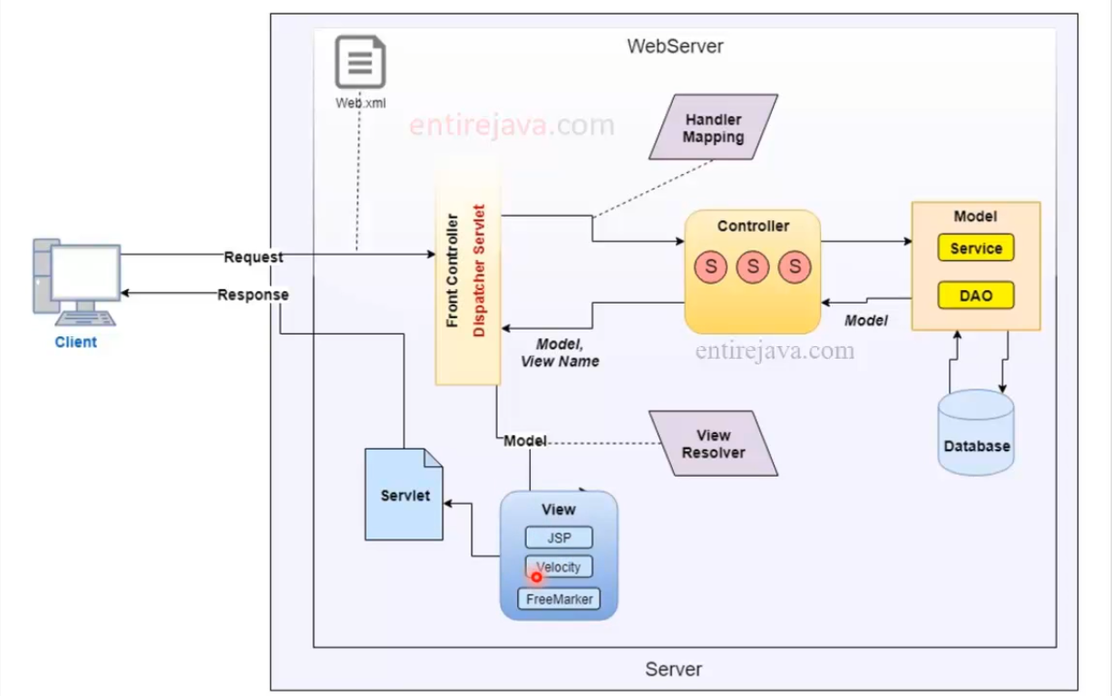

**Spring Boot**

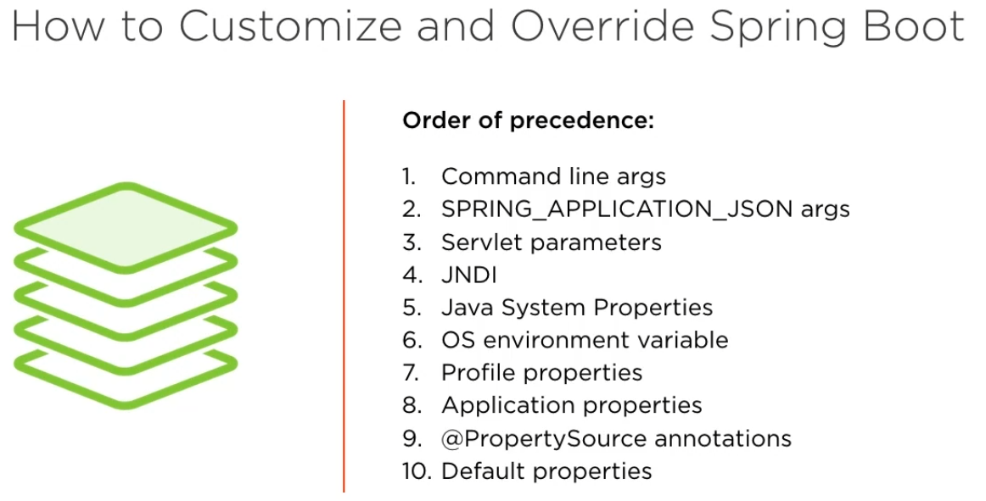

**Spring Boot with your own Auto-Configuration**

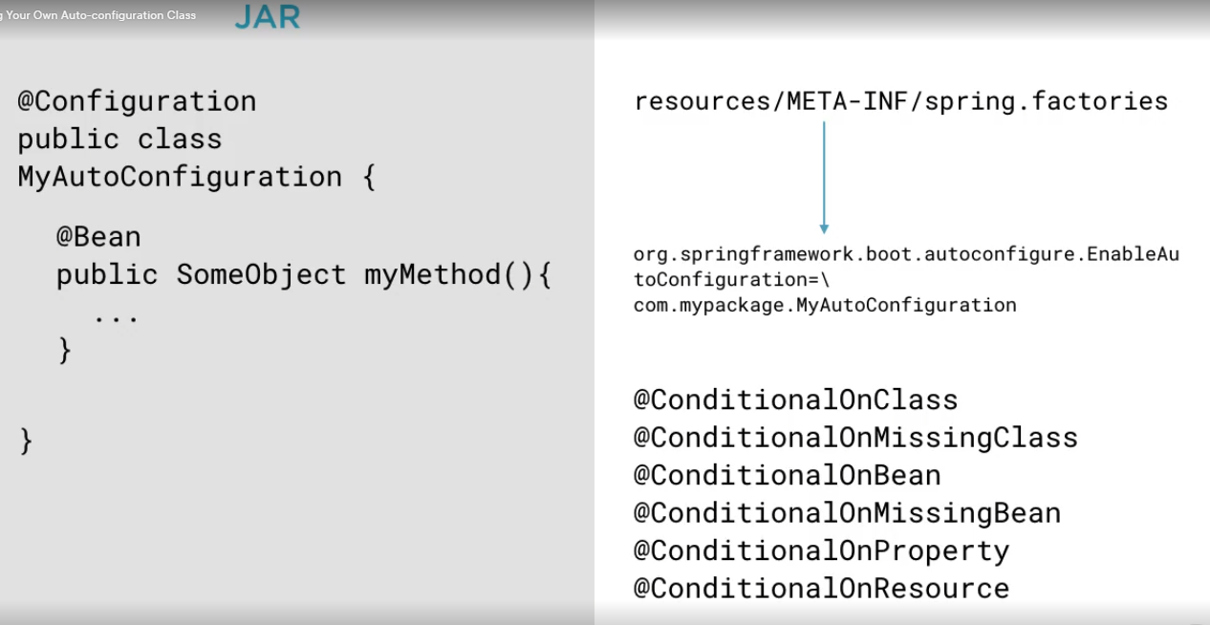

**Spring Data JPA**

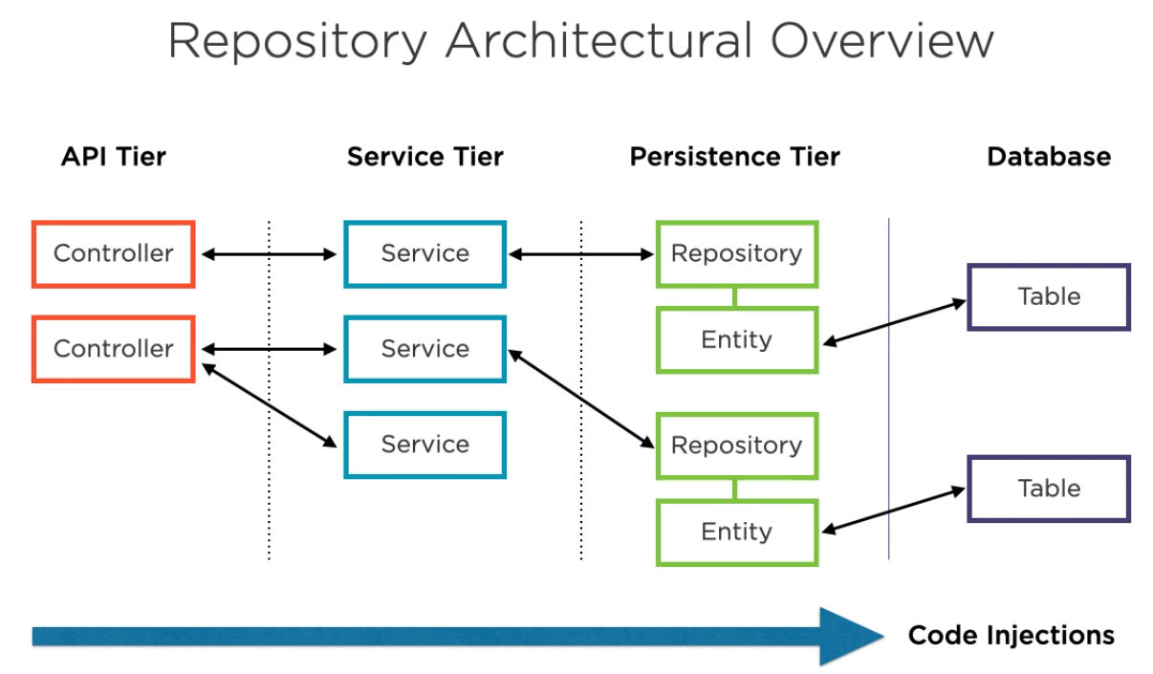

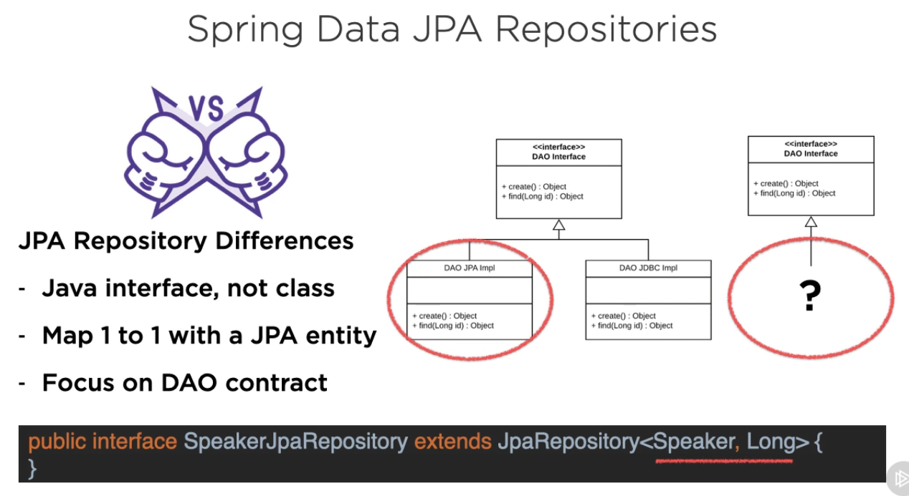

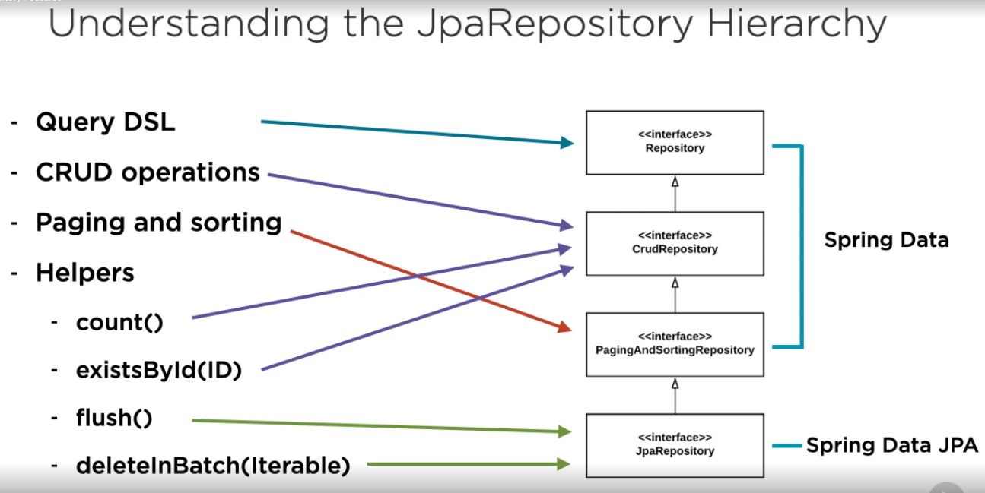

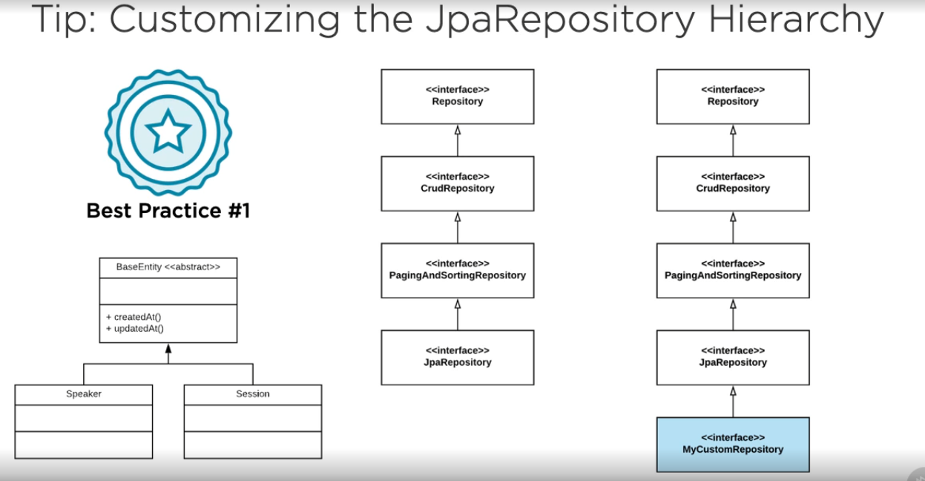

**Query DSL**

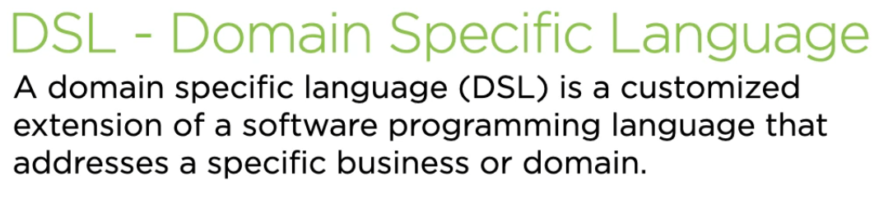

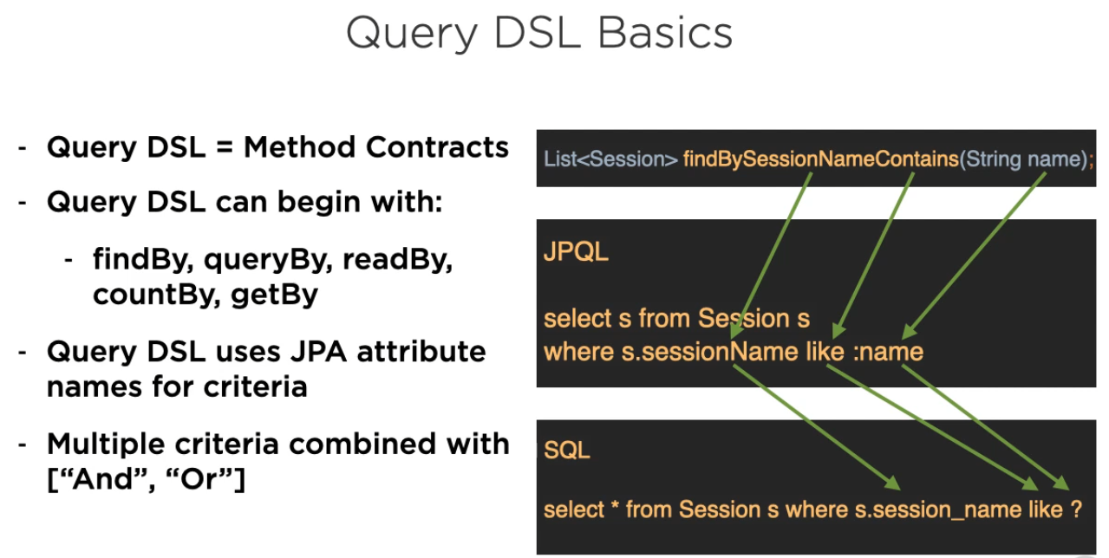

**Keywords**

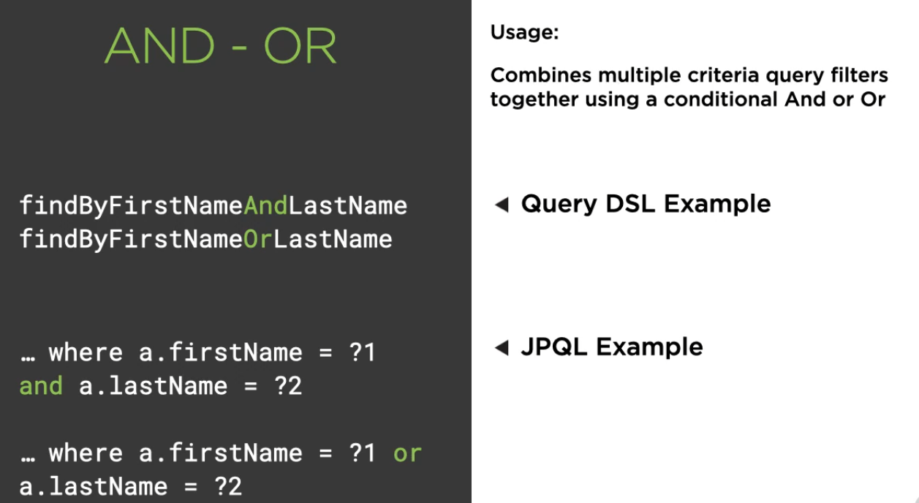

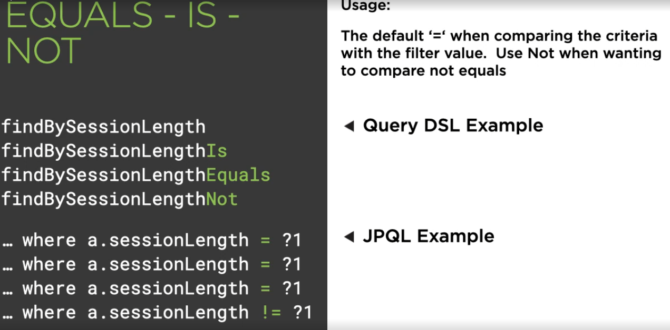

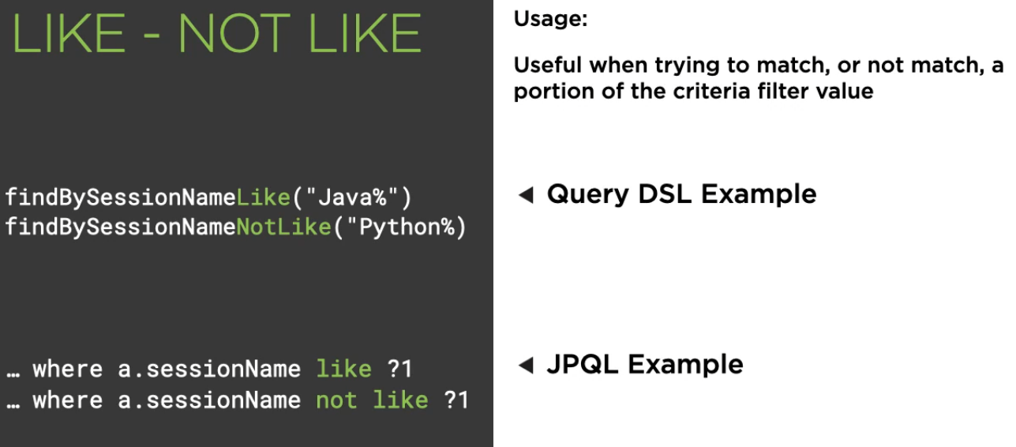

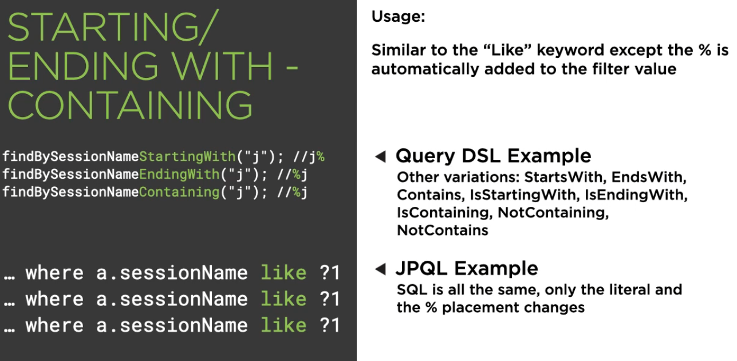

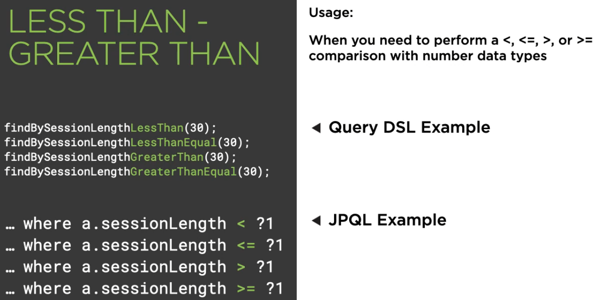

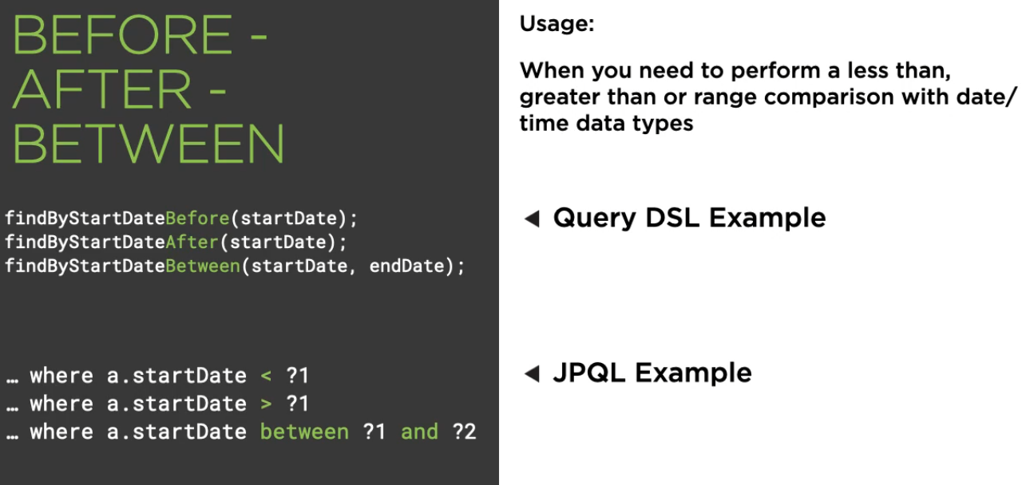

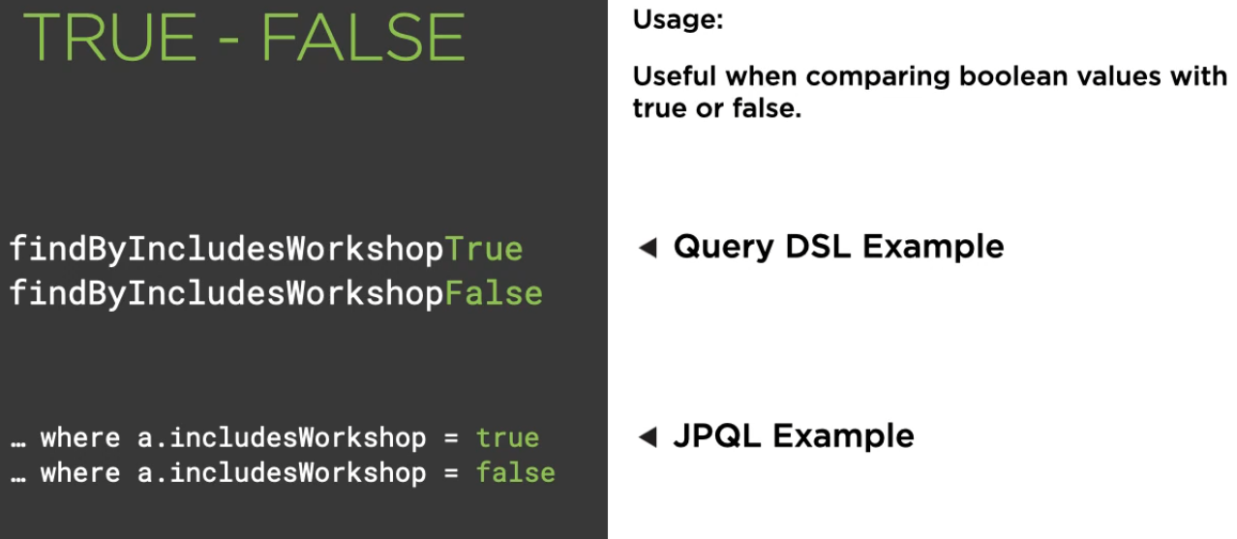

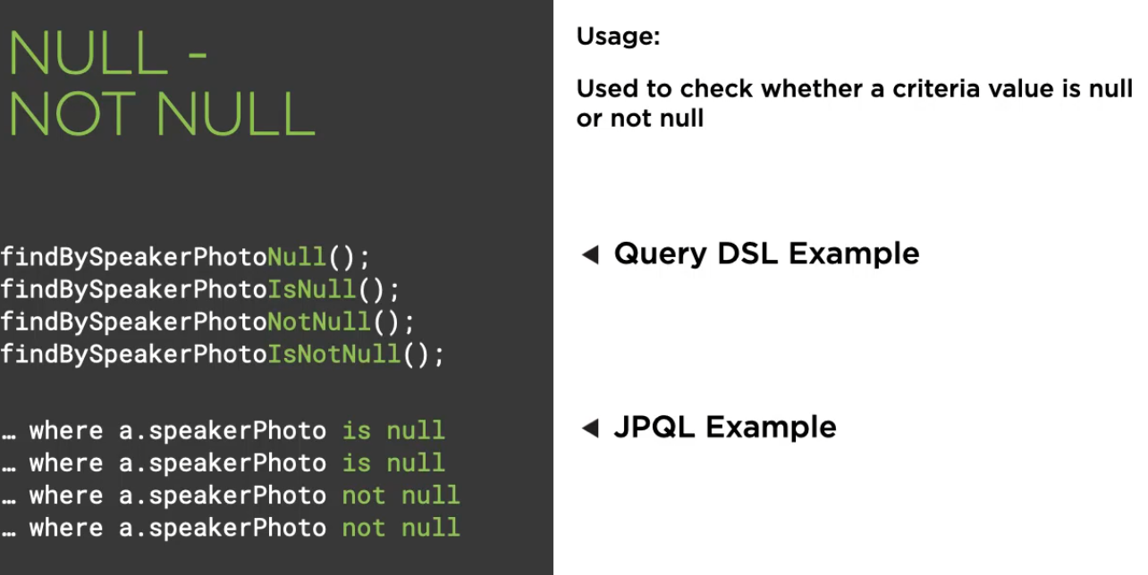

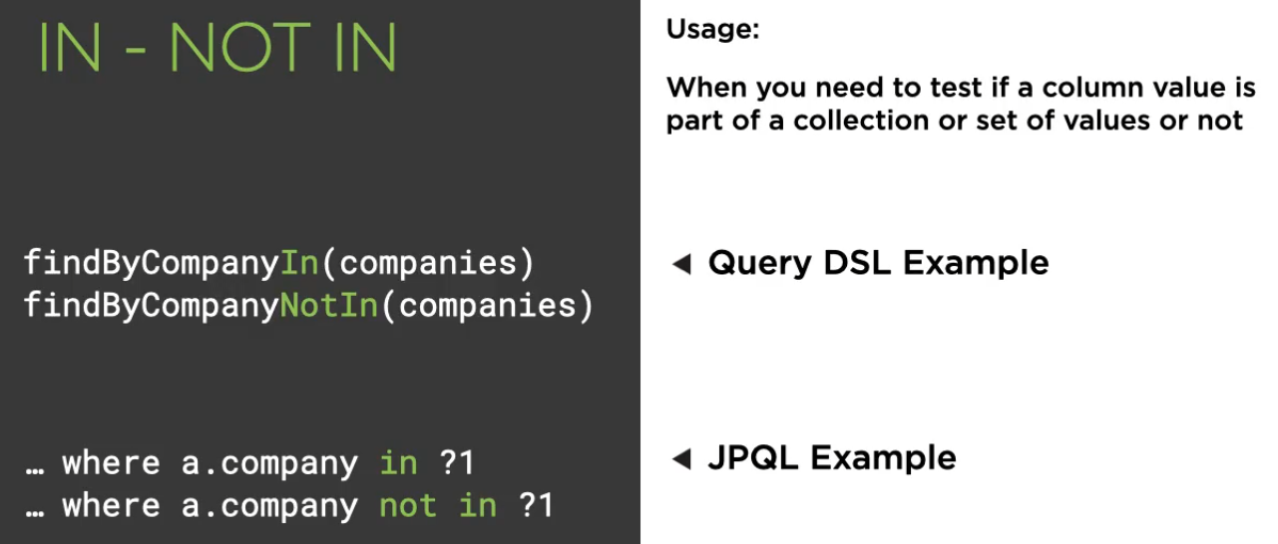

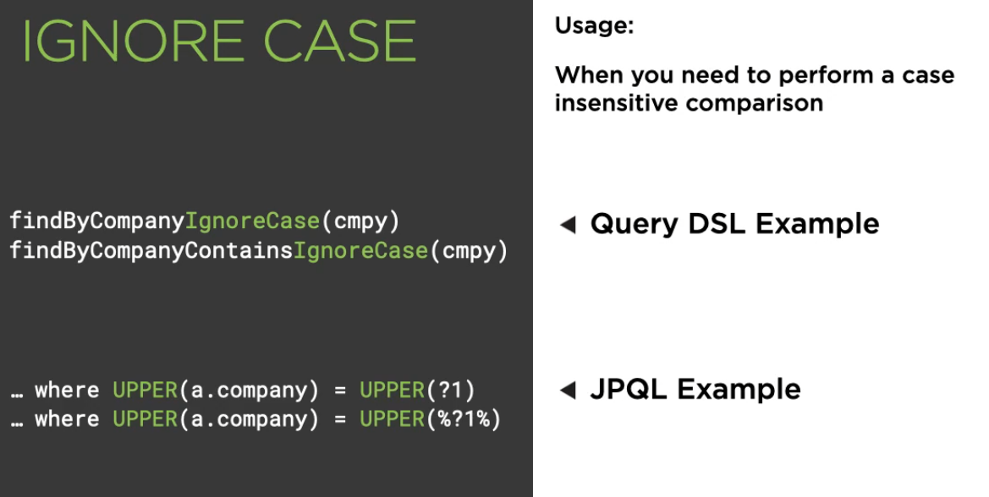

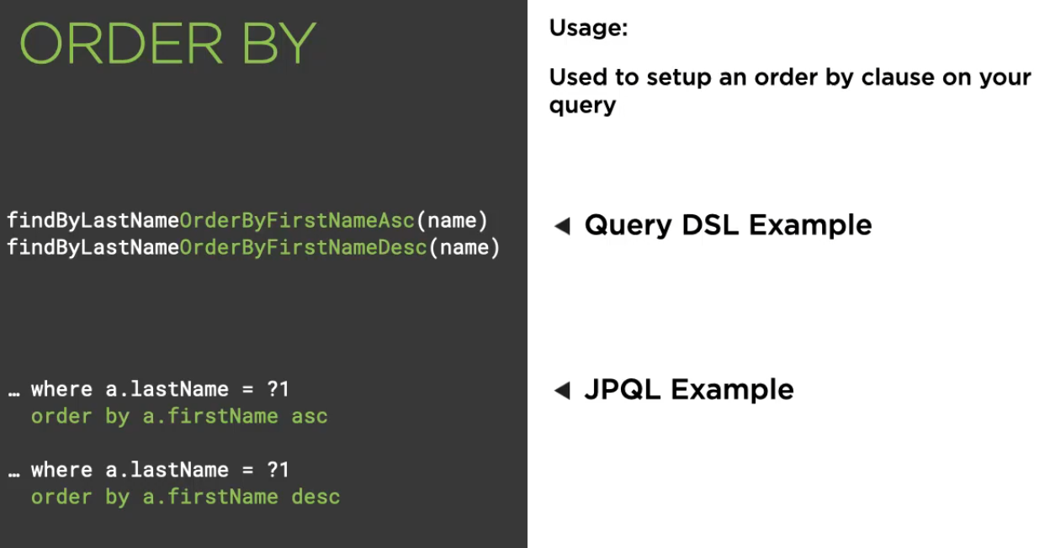

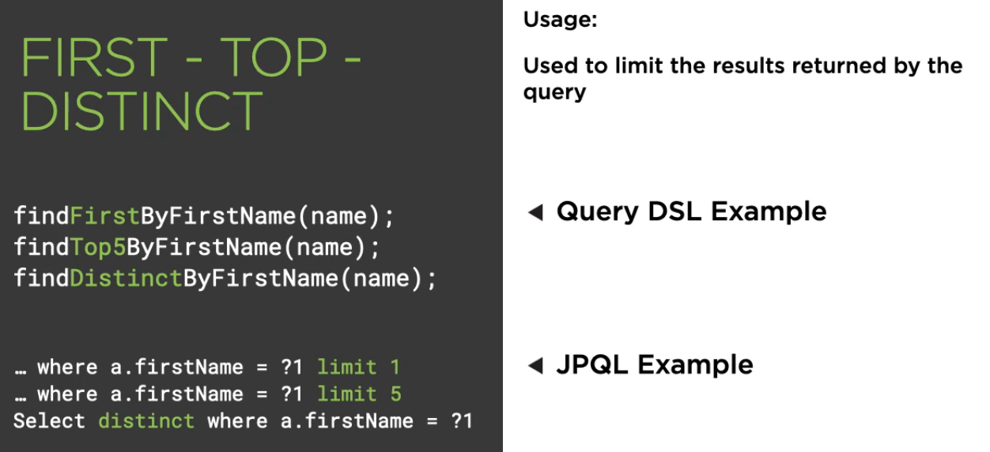

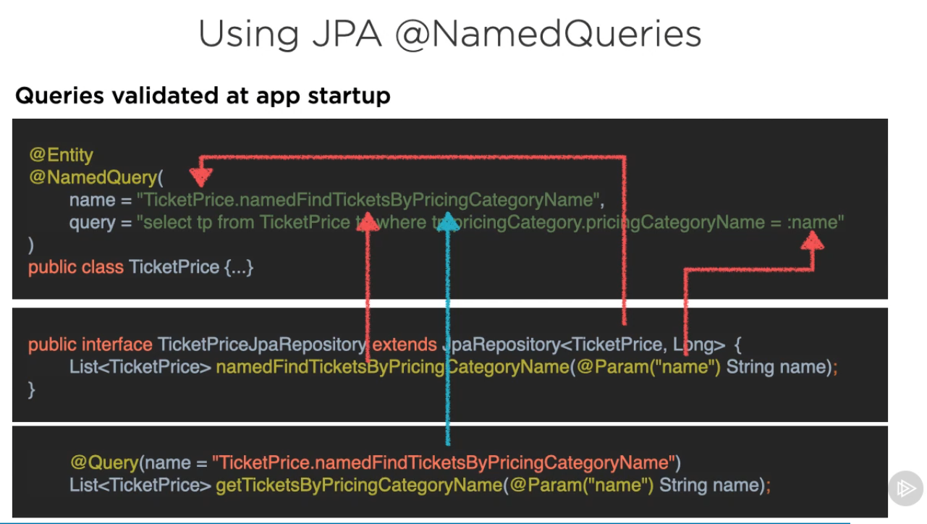

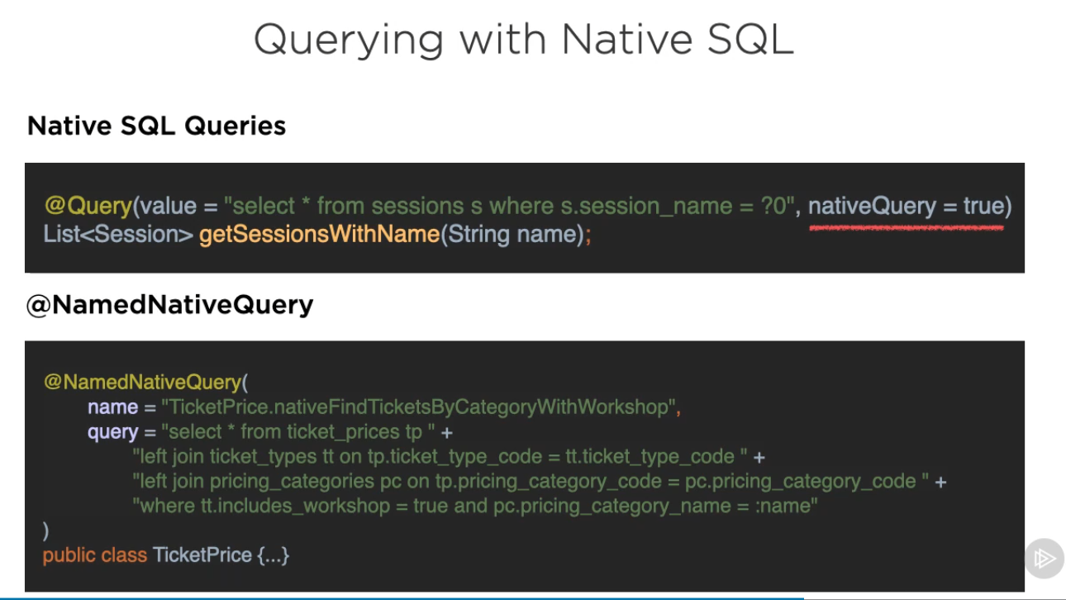

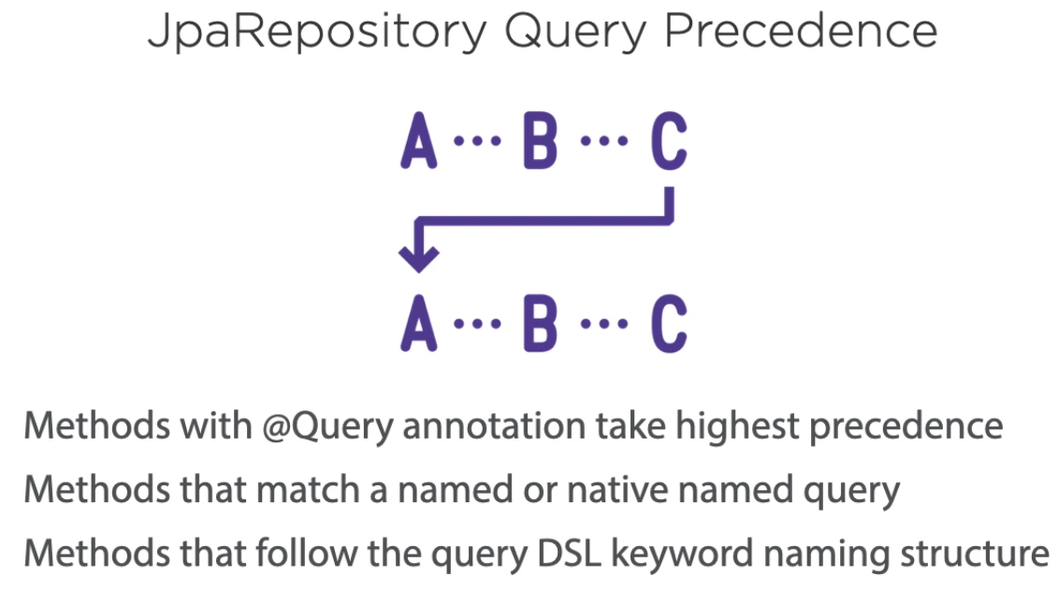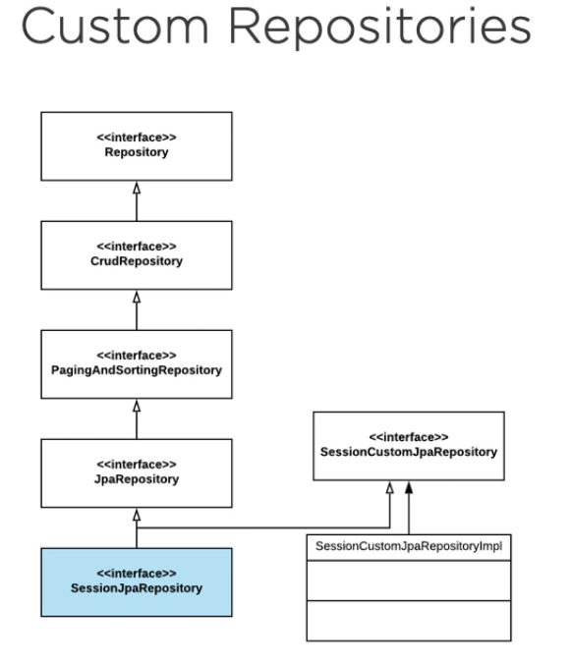

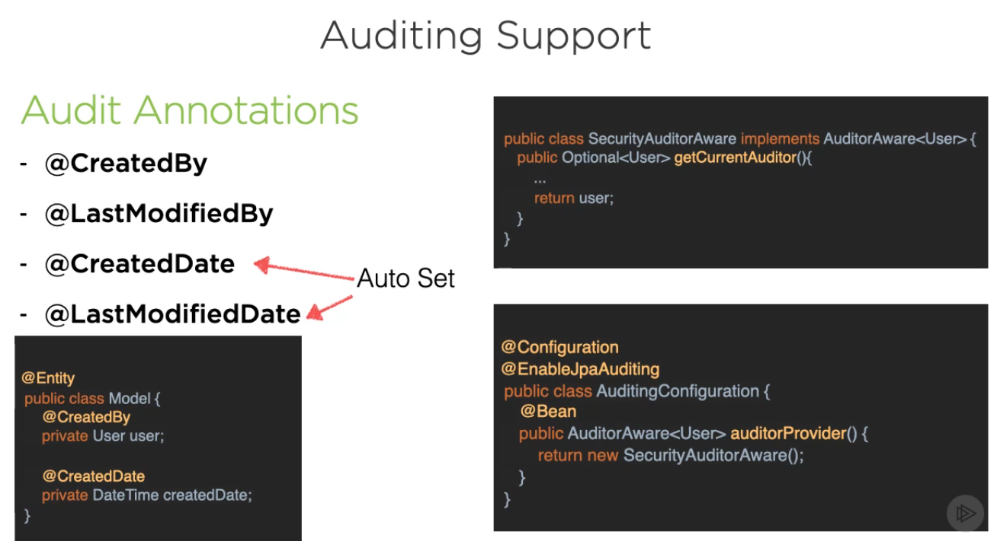

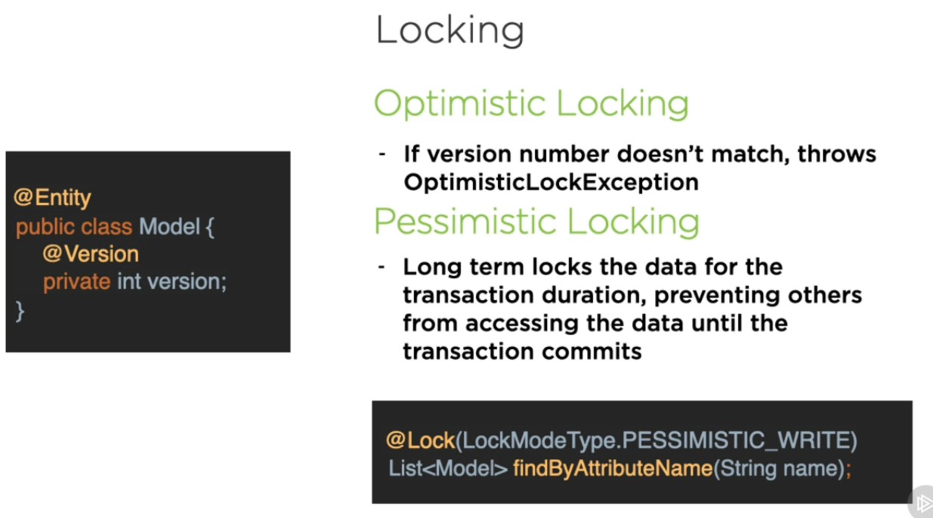

**Aspect Oriented Programming (AOP)**

